10th FEB 2017
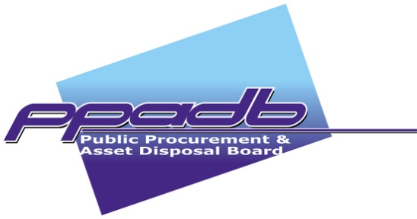
WELCOME REMARKS
Ms. JOYCE M. MOKOBI
EXECUTIVE DIRECTOR, SERVICES
PPADB MEDIA BRIEF

DATE Friday: 10th FEB 2017

TIME: 09:00 - 09:15 Hrs

@CRESTA LODGE CONFERENCE CENTRE, GABORONE

- The Director of Proceedings
- Executive Chairperson, PPADB
- Fellow Board members
- Colleagues from PPADB
- Chairperson of the Editors Forum
- Heads of Media Houses, Editors, Producers and Journalists
- Ladies and Gentlemen

- It is my pleasure to welcome you this morning to this annual Media Briefing. Section 87 (b) of the PPAD Act provides that ‘the Board shall brief the media from time to time on developments in the procurement and disposal system that are of public interest’. The last Media Brief was held in February 2016.

- The OBJECTIVE of this media briefing is therefore to continue to update the media on developments in procurement and asset disposal that are of public interest and to receive feedback from the media as we believe you are the eyes and ears of the public, and have interest in the continual improvement of tendering processes, procedures and outcomes.

- Media interactions with the Board assist PPADB to process and act on feedback to better serve its customers and stakeholders. The media also gets an opportunity to appreciate tendering issues in order to appropriately interrogate stories picked from the public domain for informed reporting.

- We have noted with gratitude that tender-related issues continue to receive coverage in your publications. This is not surprising given the importance of public procurement as an enabler in the delivery of Works, Services and Supplies. For contractors, tenders provide business opportunities hence tendering is a high stakes undertaking that is of public interest.

- The PPADB collates and analyses media reports with a view to assessing the level of media understanding of issues, public perceptions, as well as to track any issues of concern that may require the Board’s intervention particularly where such reporting is negative. We at PPADB are pleased that the media often calls on us for information to ensure balanced and accurate reporting. We wish to encourage this practice to continue as it supports public education.

- Director of Proceedings, Ladies and Gentlemen, the Board is grateful for the support and the time the media has taken to be with us this morning to interact freely and share information that will enhance the operations of the Board, and the quality of media reports on public procurement and asset disposal. We are open to provide any information that is not deemed confidential or sensitive, as per the relevant provisions of the PPAD Act.

- Thank you

